**Windows**

The backend project is based on java springboot and structure of maven. So you are suggested to install an IDE(idea myself).

1. Install maven plugin in IDE
2. Download the package in the link below, open it as a maven project with IDE
3. 图形用户界面

   AI 生成的内容可能不正确。电脑屏幕的截图

   AI 生成的内容可能不正确。Download the SQL script, new database and Run SQL Script(In datagrip myself, suppose you have mysql).
4. In forum\src\main\resources\application.yml, change the url, username and password yours in mysql. You can also change the email below

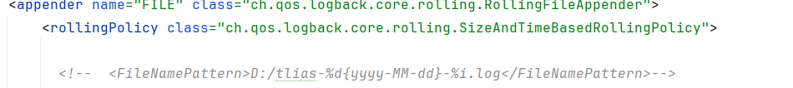

1. Make the log storage space yours in forum\src\main\resources\logback.xml
2. Run forum\src\main\java\ ForumApplication

**Deployment on Linux**

1 Prepare Docker

2.Build a docker network

2 Make a package under /usr/local/(you choose a name) and enter it

3 Download Dockerfile on github

Prepare forumParent-0.0.1-SNAPSHOT.jar

(If you successfully run 6. Run forum\src\main\java\ ForumApplication above, click package in Maven lifecycle)

Download jdk-17.0.12_linux-x64_bin.tar.gz on

https://www.oracle.com/java/technologies/javase/jdk17-archive-downloads.html

and upload them to the package.

4 Download mysql by referring to the order below:

docker run -d \

--name mysql \

--network your_networkname \

-p 3333:3306 \ (choose a port as you like, not really 3333)

-e TZ=Europe/London \

-e MYSQL_ROOT_PASSWORD=yours \(your personal mysql password)

-v mysql-data:/var/lib/mysql \

mysql:8.0

5 Connect the mysql in your personal computer. Download the SQL script, new database and Run SQL Script(In datagrip myself).

6 Build the project as an image in docker. Suggested order:

docker run -d \

--name forum-server \

--network net1 \

-p 8080:8080 \

-e DB_URL="jdbc:mysql://mysql:3307/forum" \

-e DB_USER="root" \

-e DB_PASSWORD="yours" \

forum-app

7 Now it should start to work. Use “docker ps” to check if forum-server and mysql is running.

8 If you wish to try send verification code and upload file, you have to change the email config and have an OSS account. Don’t forget to add your oss secret key in Dockerfile or local environmental variables.